**MECH 3409: Machine Design Elements**

**Group C - Final Report**

Prepared by:

| **Amish SAJIKUMAR** |  |
| --- | --- |
| **Muhammad FARHAN** |  |
| **Nathan HSIEH** |  |
| **Obada WAZWAZ** |  |

# 1.0 TABLE OF CONTENTS

**1.0 TABLE OF CONTENTS** **2**

**2.0 INTRODUCTION** **4**

**3.0 IDEA GENERATION AND CONCEPT SELECTION** **4**

3.1 Idea Generation 4

3.1.1 Frame Idea Generation 4

3.1.2 Seat Idea Generation 5

3.1.3 Front Fork / Handlebar Idea Generation 5

3.1.4 Pedal Idea Generation 6

3.1.5 Gearbox Idea Generation 6

3.2 Concept Selection 7

**4.0 PRELIMINARY DESIGN** **7**

**5.0 ANALYSIS AND ITERATIVE DESIGN** **9**

5.1 Yield Strength and Young’s Modulus 9

5.1.1 Aluminum 6061 Alloy 9

5.1.2 EPDM Rubber 9

5.1.3 Carbon Fiber 9

5.2 Free Body Diagrams and Calculations 10

5.2.1 Free Body Diagram: Frame 10

5.2.2 Free Body Diagram: Seat 10

5.2.3 Free Body Diagram: Pedal 11

5.2.4 Free Body Diagram: Front Fork / Handlebar 11

5.3 Maximum Stress to Gears 12

5.3.1 Maximum Stress to Gear 1 12

5.3.2 Maximum Stress to Gear 2 12

5.3.3 Maximum Stress to Gear 3 12

5.4 Applied Stress to Gears 12

5.4.1 Applied Stress to Gear 1 12

5.4.2 Applied Stress to Gear 2 12

5.4.3 Applied Stress to Gear 3 12

5.5 Factor of Safety and Design Optimization 13

**6.0 FINAL DESIGN** **13**

6.1 Factor of Safety for Static Loading 14

6.2 Fatigue Lifetime Under Cyclic Loading 15

6.3 Auxiliary Parts 15

6.3.1 Battery Specifications 15

6.3.2 Motor Specifications 15

6.3.3 Auxiliary Assembly Components 15

6.4 Bill of Materials 16

**7.0 APPENDICES** **17**

7.1 Appendix A: References 17

7.2 Appendix B: Assembly Drawing 17

7.3 Appendix C: Engineering Drawings of Individual Parts 18

7.3.1 Bike Frame Engineering Drawing 18

7.3.2 Seat Engineering Drawing 18

7.3.3 Front Fork / Handlebar Engineering Drawing 19

7.3.4 Pedal Engineering Drawing 19

7.3.6 Motor Engineering Drawing 20

7.4 Appendix D: Detailed Data from FEM 21

7.4.1 Stress Analysis - Frame 21

7.4.2 Strain Analysis - Frame 21

7.4.3 Displacement Analysis - Frame 21

7.4.4 Stress Analysis - Seat 22

7.4.5 Strain Analysis - Seat 22

7.4.6 Displacement Analysis - Seat 22

7.4.7 Stress Analysis - Pedal 23

7.4.8 Strain Analysis - Pedal 23

7.4.9 Displacement Analysis - Pedal 23

7.4.10 Stress Analysis - Front Fork / Handlebar 24

7.4.11 Strain Analysis - Front Fork / Handlebar 24

7.4.12 Displacement Analysis - Front Fork / Handlebar 24

7.5 Appendix E: List of Tables 25

7.6 Appendix F: List of Figures 25

7.7 Appendix G: Force Calculations 26

7.7.1 Frame Force Calculation 26

7.7.2 Seat Force Calculation 26

7.7.3 Pedal Force Calculation 26

7.7.4 Handlebar Force Calculation 27

7.8 Appendix H: Attribution Table 27

# 

# 2.0 INTRODUCTION

To combat climate change, the incorporation of motorized / electric vehicles has been highly supported amongst all levels of government (ie. municipal, provincial, federal and international) as a means of minimizing greenhouse gas (GHG) emissions. The objective of this report is to identify possible design solutions to local methods of transportation via electric bike (e-bike). By generating various component designs, we are able to create various concept designs as well as improvise and adapt the most suitable variation to satisfy the design objectives as listed in the *Design Specification Report* document.

# 3.0 IDEA GENERATION AND CONCEPT SELECTION

Before we began creating a design, our method in developing the most suitable design relied on a concept called “Rational Choice Theory”. Essentially, we developed different designs for each of the components as listed in our *Design Specification Report* and selected the best components to suit our needs. This allows us to modify our design easily depending on potential altering conditions. As listed in the *Design Project Topic* file, the conditions include a 65 kg rider with a lifetime assumed to be 8 years, 3 km/day average riding distance in laboratory conditions.

## 3.1 Idea Generation

### 3.1.1 Frame Idea Generation

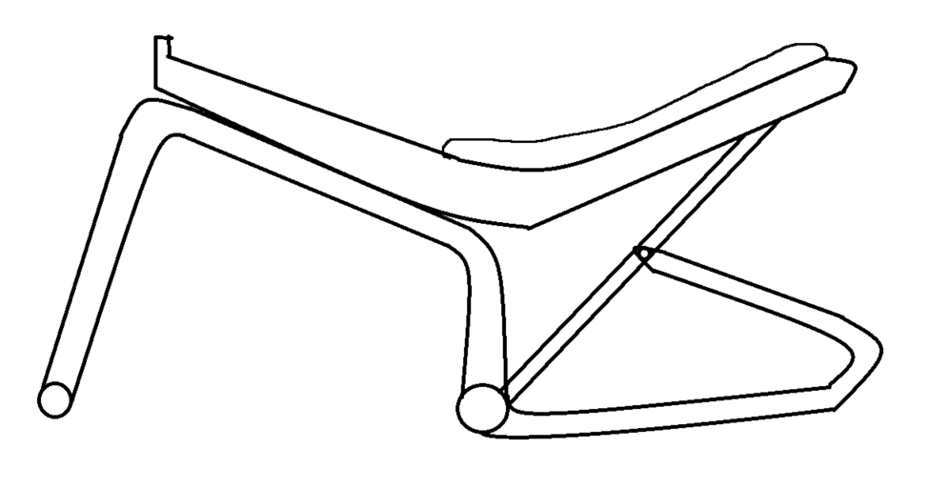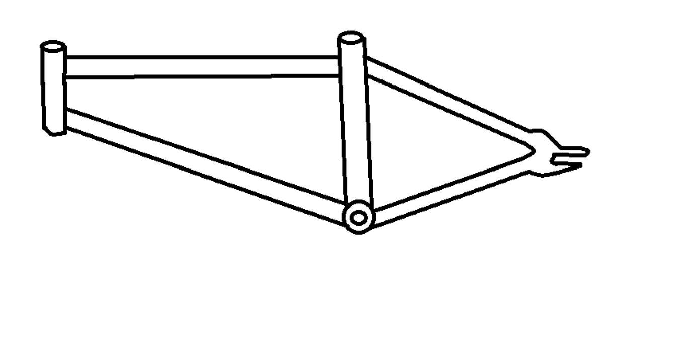

| Frame #1 | Frame #2 | Frame #3 |
| --- | --- | --- |
| * Most conventional design * Practical, easy to manufacture * Compatible to fit a drivetrain and a gearbox * Simplistic design may not appeal to customers | * More rigid compared to other designs * Rider’s weight is distributed significantly throughout the bike (triangle shape = most stable) * Riders may have to bend down low (impacts Field of View | * Comfortable riding position * Complex design, difficult to manufacture * Less aerodynamic than conventional frame designs * Incompatible with drivetrain/gearbox designs |
| *Table 1. Frame Idea Generation.* | | |

### 3.1.2 Seat Idea Generation

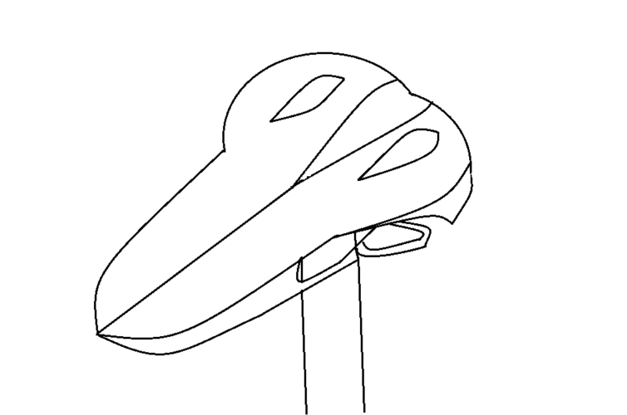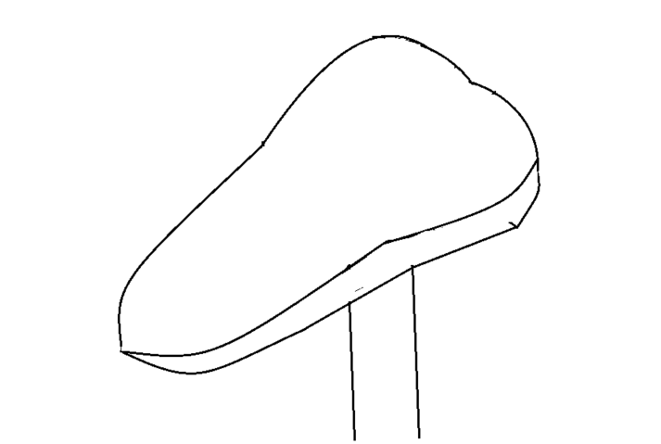

| Seat #1 (Racing Saddle Design) | Seat #2 (Comfort Saddle Design) | Seat #3 (Cruiser Seat) |
| --- | --- | --- |
| * Provides full movement * Designed to prevent chafing * Uncomfortable for long distances (flatter surface) * Thinner and may be difficult for a large number of riders | * Large amounts of padding for comfort + easy pedalling * Designed to absorb vibrations * Larger size saddle, may not be suitable for all * More suitable for female riders | + Large amounts of cushioning and support on both ends  + Weight is directly on the seat, fits all body types   * Designed to help “cruise”, not designed for full pedalling |
| *Table 2. Seat Idea Generation.* | | |

### 

### 3.1.3 Front Fork / Handlebar Idea Generation

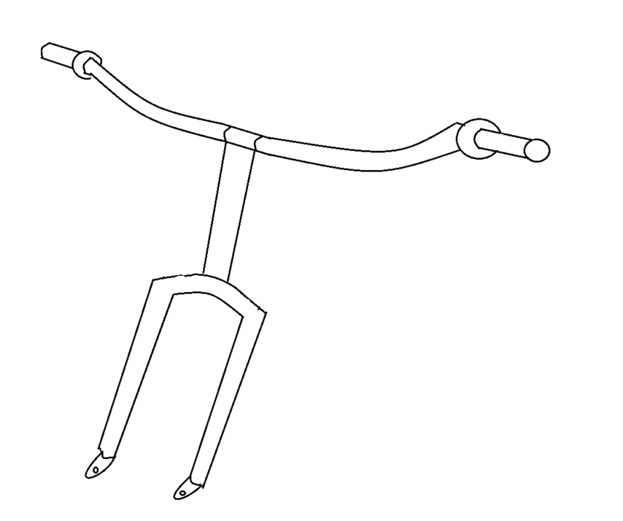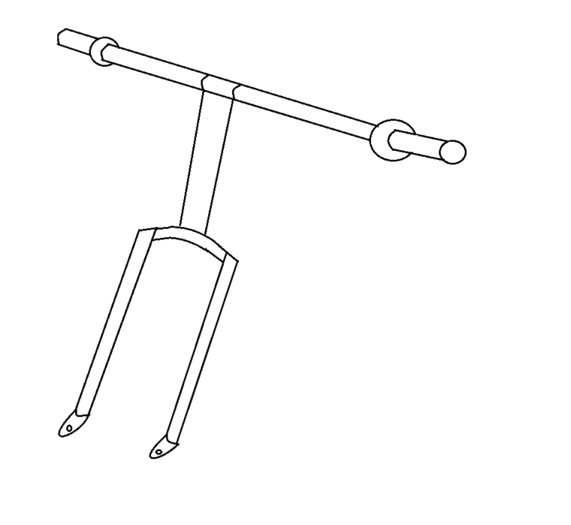

| Handlebar #1 (Flat Handlebars) | Handlebar #2 (Riser Handlebars) | Handlebar #3 (Drop Handlebars) |
| --- | --- | --- |
| * Most conventional design * Not good for speed (hard to go into tuck position) * Not optimal for free riding | * More control, more comfortable for wrists and better for free riding * Bad aerodynamics, not good for climbing | * Great aerodynamics and are highly versatile * Better leverage for pedalling * Not good for frequent tight turns |
| *Table 3. Front Fork / Handlebar Idea Generation.* | | |

### 

### 3.1.4 Pedal Idea Generation

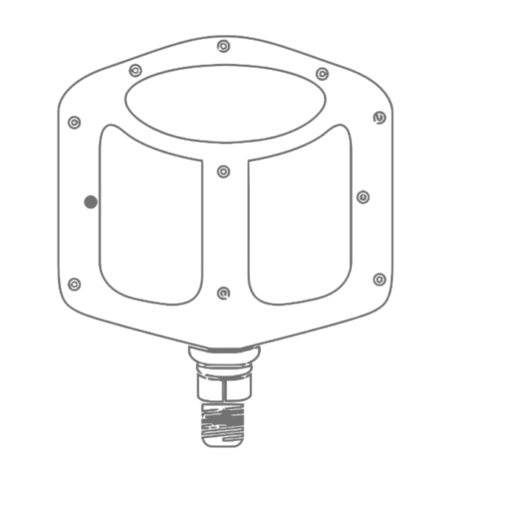

| Pedal #1 (Platform Pedals) | Pedal #2 (Road Clipless Pedals) | Pedal #3 (Cage Pedals) |
| --- | --- | --- |
| * Most conventional design * Practical, easy to manufacture * Universal standard * Lose full power of pedal stroke (upstroke) * Easy for foot to fly off the pedal or hit shin | * Most efficient pedal stroke * Don’t get full power from pedaling * Foot may slide off due to how thin some options are * Special shoes are attached to the pedals | * Can be used with any footwear * Beginner-friendly * More secure than platform pedal * Loses significant amount of power from pedal strokes * Riders may fall if they forget to unclip shoe before stopping |
| *Table 4. Pedal Idea Generation.* | | |

### 3.1.5 Gearbox Idea Generation

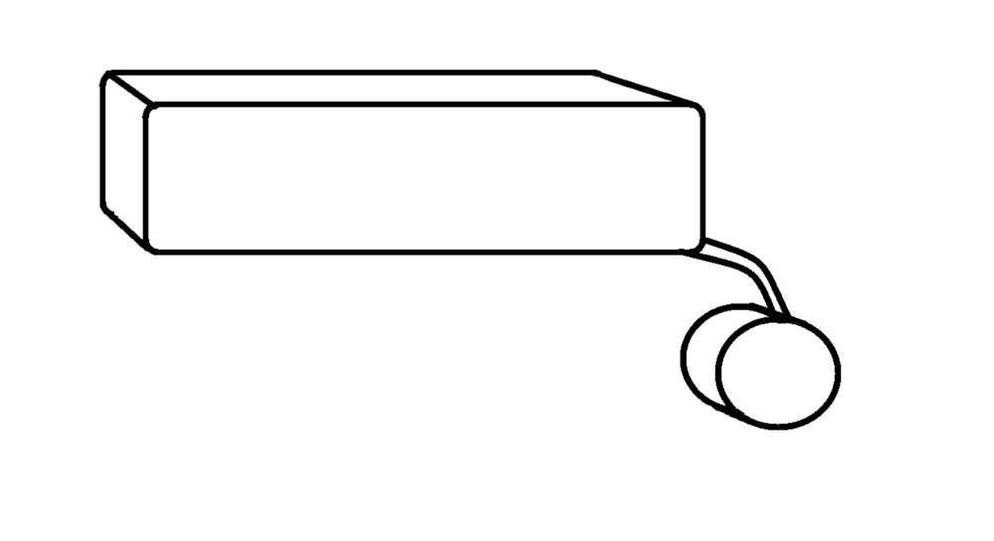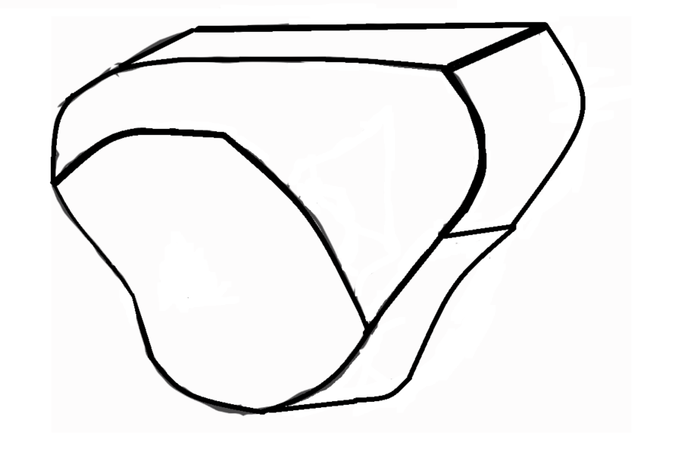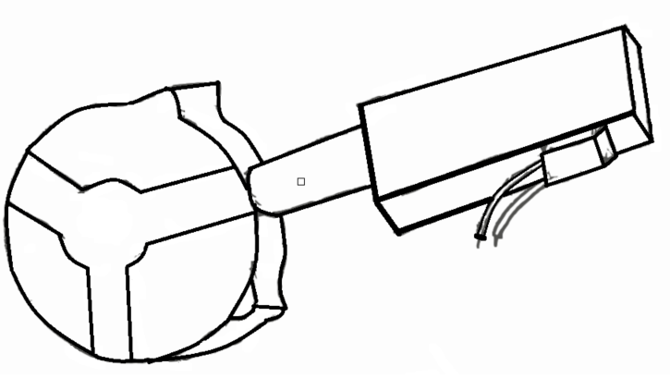

| Gearbox #1 | Gearbox #2 | Gearbox #3 |
| --- | --- | --- |
| * Simplistic and compact design * Encasing is easy to manufacture and assemble * Easy to incorporate into frame designs * Slightly longer compared to alternative designs * Difficult to fit larger size gears | * Easy to incorporate into frame designs * Difficult to manufacture and assemble * May not be able to fit larger gears depending on the size | * Easier to fit larger size gears * Difficult to manufacture and assemble * Slightly wider compared to alternative designs (bulkier) * May interfere with pedalling motion |
| *Table 5. Gearbox Idea Generation.* | | |

## 3.2 Concept Selection

With a side-by-side comparison of component options, we selected the components that will be used for our preliminary design:

Frame: Frame #2 - was more conventional and was the most compatible for our

conditions as it provided us the most space to mount a drivetrain, a gearbox, a motor and a battery.

Seat: Cruiser Seat - provided the most comfort for the rider and was mostly

suited for cruising and less pedalling. Because the rider was expected to use the motor mostly, this seat was the best option.

Handlebar: Riser Handlebars - provided more control for urban riding and was better

on the wrists of the riders. Compared to alternative designs, tight turns may be needed due to the nature of most indoor laboratories.

Pedals: Platform Pedals - most conventional and practical design, suited for all

riders as they are considered beginner pedals. Because it is the most universal design, easy to replace if damaged. Although pedalling power is lost, the use of the motor allows the rider to simply rest on the pedals.

Gearbox: Gearbox #1- was the most simplistic option from the generated ideas and

was the most adaptable to all of the frame design options. Due to the smaller scaled size, this provided adequate amounts of space for various motor and battery selections compared to the other gearbox designs.

# 4.0 PRELIMINARY DESIGN

Comparing the various component concepts and selecting the most suitable variation for our needs, we were able to create a preliminary design to serve as a basis for our final design. Because we expect the e-bike to be used in mostly laboratory settings, we selected components that kept the design as minimal as possible to reduce material and manufacturing costs as well as allocating enough space for the motor and battery. This was important since it allows the rider to interchange all components (including the motor and the battery) to meet different scenarios. For example, this includes installing a larger battery for longer-distance travelling / use or installing a more powerful motor for heavier riders or uphill travelling. For our intended conditions (ie. laboratory conditions), it is crucial that our design is lightweight and effective at transporting the rider. As a result, we are able to select materials without certain concerns such as corrosion.

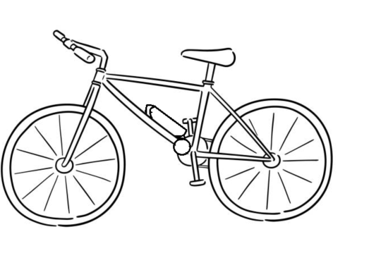

*Figure 1.0: Preliminary design of the electric bike and selected components.*

Our preliminary design included a simplistic bike design with a gearbox mounted on the down tube of the bike frame. However, we would design the components with an emphasis on cruising, and less so on pedalling. Although the bike will remain rigid, we sacrificed some rigidity for reducing weight due to the use of the bike being indoors. This is because we do not expect the bike to experience any significant impact (e.g. getting hit by a car) but, we intend to ensure that the bike has an extensive lifetime prior to failure. In order to keep our bike as light and rigid as possible, the following materials have been selected for the components:

| **Component** | **Material** |
| --- | --- |
| Frame | Aluminum 6061 Alloy |
| Seat | Aluminum 6061 Alloy / EPDM Rubber |
| Front Fork / Handlebar | Aluminum 6061 Alloy |
| Pedals | Carbon Fiber |
| Gearbox | Aluminum 6061 Alloy |

*Table 6. Material selection for components.*

Because the bike will be used for short distance travelling (3 km/day), we aim to focus on comfort for the rider to enjoy using the bike as a method of transportation. To remain in a comfortable riding position on the bike, the following table lists key dimensions for the components:

| **Parts** | **Dimensions (cm)** | |
| --- | --- | --- |
| Frame | Length | 127.79 |
| Width | 43.99 |
| Height | 103.778 |
| Seat | Length | 43.564 |
| Width | 47.656 |
| Height | 18.078 |
| Front Fork / Handlebar | Length | 11.308 |
| Width | 86.723 |
| Height | 25.136 |
| Pedals | Length | 10.04 |
| Width | 7.004 |
| Height | 3.004 |
| Gearbox | Length | 15.27 |
| Width | 5.5 |
| Height | 14.28 |

*Table 7. Key dimensions for components.*

# 5.0 ANALYSIS AND ITERATIVE DESIGN

## 5.1 Yield Strength and Young’s Modulus

### 5.1.1 Aluminum 6061 Alloy

$UTS=290 MPa$ $TYS=110 MPa$ $E=68 GPa$

### 5.1.2 EPDM Rubber

$UTS=17 MPa$ $TYS=16 MPa$ $E=100 MPa$

### 5.1.3 Carbon Fiber

$UTS=3.5 GPa$ $TYS=3.2 GPa$ $E=228 GPa$

## 5.2 Free Body Diagrams and Calculations

### 5.2.1 Free Body Diagram: Frame

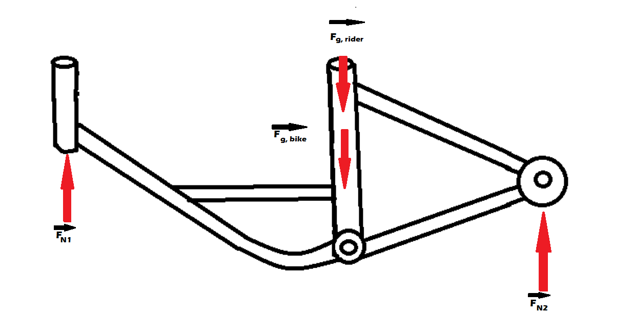

*Figure 2.0: Free body diagram showing the forces acting on the frame.*

The frame must be able to withstand 750 N of force at the head tube ( $704.358$ N [actual]) as well as 400 N of force at the seat stays and chain stays ( $352.179$ N [actual]). See *Appendix 7.6.1* for force calculations.

(Note: $F_{N2}$ is the combined force for two segments of the seat stays / chain stays.)

### 

### 5.2.2 Free Body Diagram: Seat

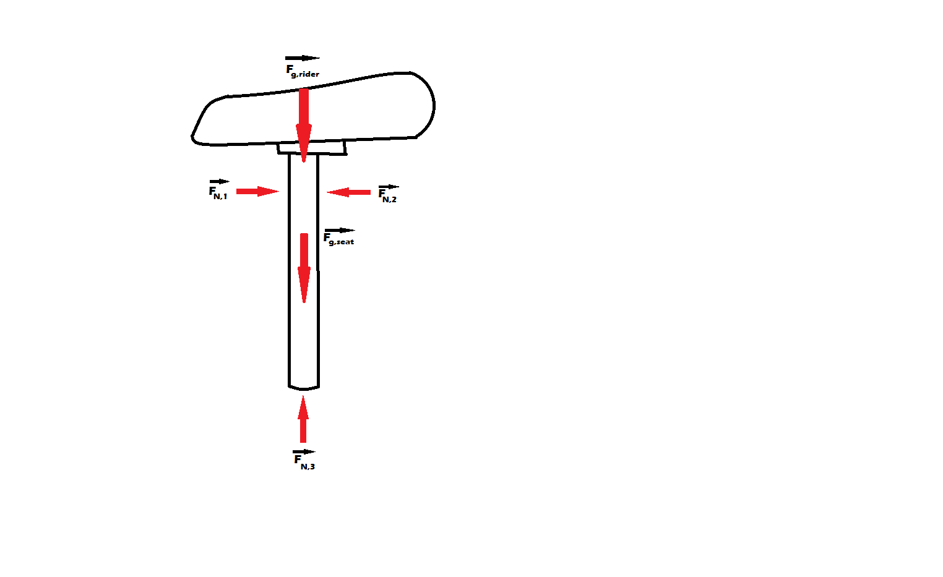

*Figure 2.1: Free body diagram showing the forces acting on the seat.*

### 

The frame must be able to withstand 700 N of force at the supporting tube ( $653.346$ N [actual]). See *Appendix 7.6.3* for force calculations.

(Note: $F_{N1}$, $F_{N2}$ and $F_{N3}$ are distributed loads but a point load was taken to estimate component failure.)

### 

### **5.2.**3 **Free Body Diagram: Pedal**

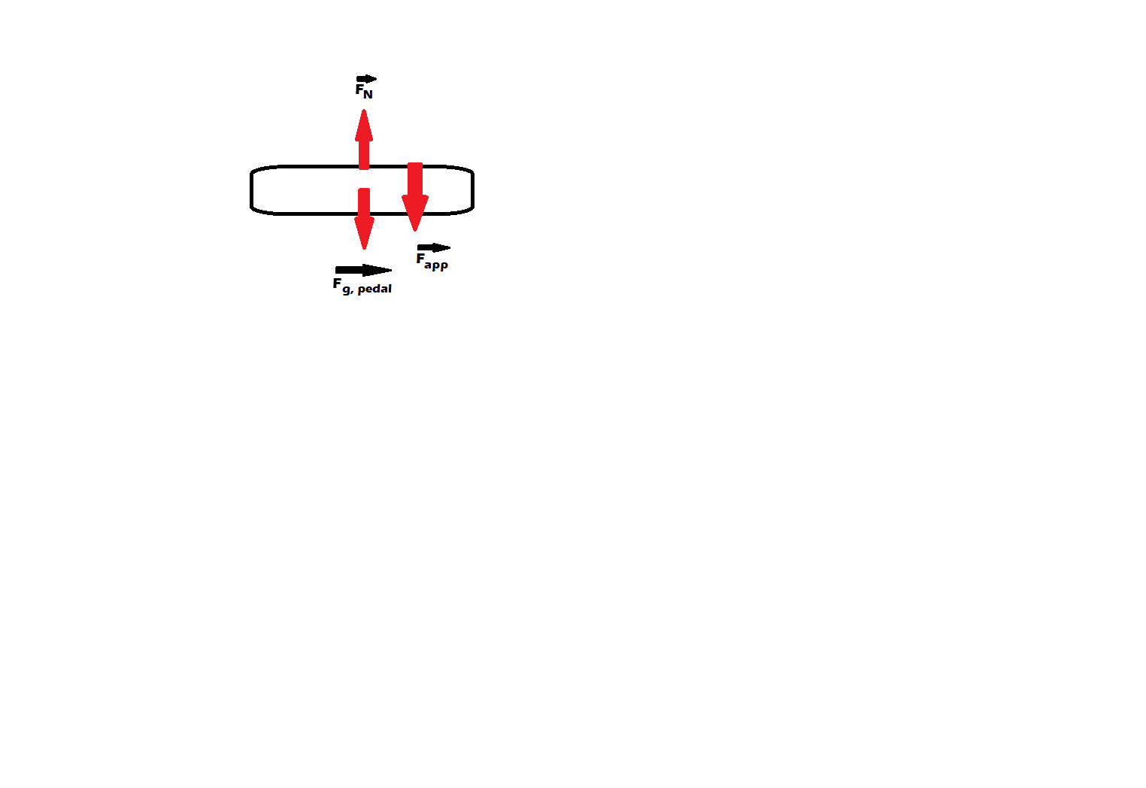

*Figure 2.2: Free body diagram showing the forces acting on the pedal.*

Each pedal should be able to withstand at $400$ N of force without any deformation or failure ( $321.572$ N [actual]). See *Appendix 7.6.4* for force calculations.

(Note: This value assumes that the rider equally pedals the same and does not excessively apply a load on one specific pedal.)

### 5.2.4 Free Body Diagram: Front Fork / Handlebar

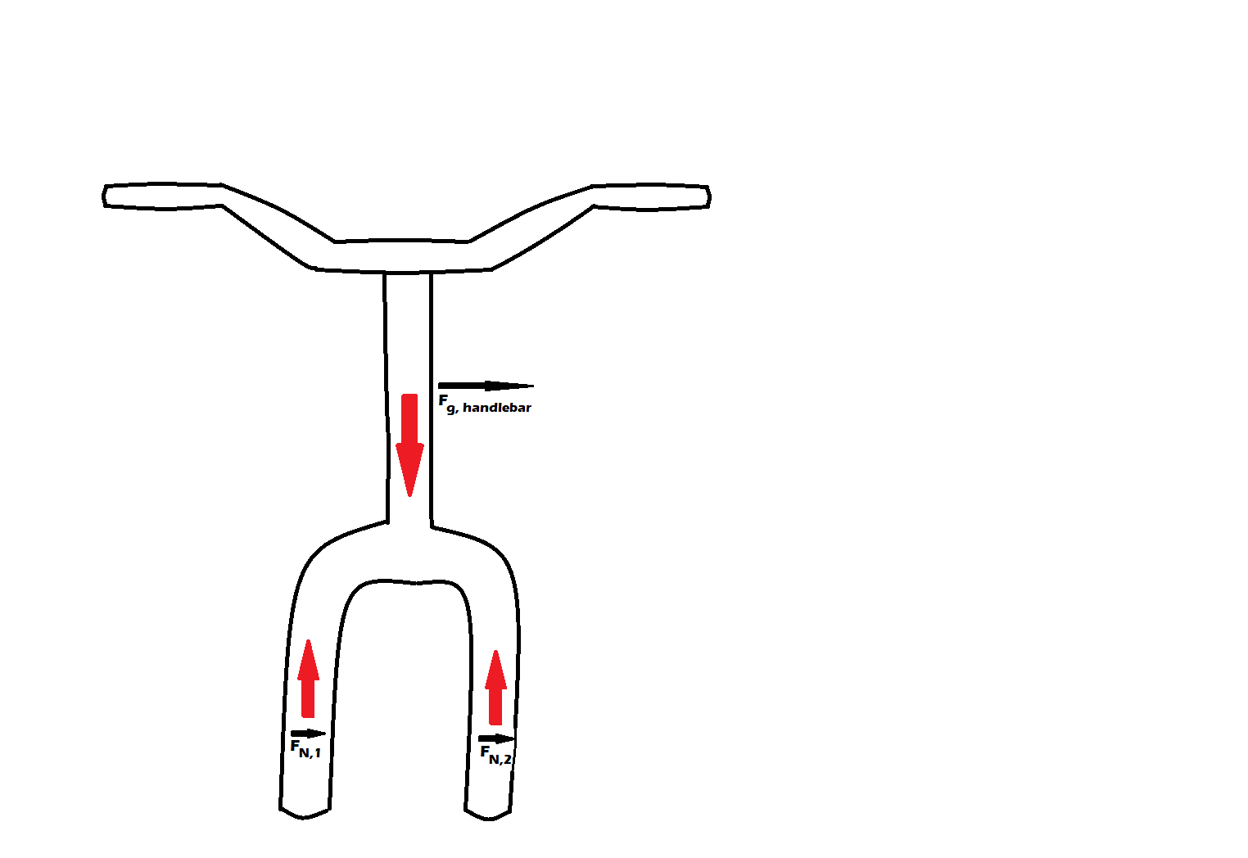

*Figure 2.3: Free body diagram showing the forces acting on the front fork / handlebar.*

The front fork must be able to withstand a combined force of 100 N without any deformation or failure ( $41.202$ N [actual]). See *Appendix 7.6.5* for force calculations.  
(Note: $F_{N12}$ is the combined force of $F_{N1}$ and $F_{N2}$. Although both sides of the front fork are identical, they both may be subjected to different loads (but the same combined load) when turning / tilting while riding.)

## 5.3 Maximum Stress to Gears

From the force calculations, we calculated the maximum stress that the gears may tolerate from the applied force of the rider. These values also take into consideration the torque applied from the motor (Note: Please see the *Excel Calculations* file for maximum stress calculations. The gear ratio was assumed to be 1:100).

### 5.3.1 Maximum Stress to Gear 1

$σ_{gear 1}=85235.74 Pa$

### 5.3.2 Maximum Stress to Gear 2

$σ_{gear 2}=$ 12969.52 Pa

### 5.3.3 Maximum Stress to Gear 3

$σ_{gear 3}=$ 85235.74 Pa

## 5.4 Applied Stress to Gears

### 

The applied stress to the gears was calculated from the torque applied from the motor. Because the rider is expected to only use the pedals in emergency situations (ie. the battery or motor fails), each rider applies different stresses for the gear. In the following calculations, only the applied stress from the motor was taken into consideration (reference *Section 6.3.2*. Note: Please see the *Excel Calculations* file for applied stress calculations. The gear ratio was assumed to be 1:100).

### 5.4.1 Applied Stress to Gear 1

$σ_{gear 1}=33486.13 Pa$

### 5.4.2 Applied Stress to Gear 2

$σ_{gear 2}=5095.27 Pa$

### 

### 5.4.3 Applied Stress to Gear 3

$σ_{gear 3}=33486.13 Pa$

## 5.5 Factor of Safety and Design Optimization

From our initial component designs, we were able to calculate the factor of safety for all of the major components. As listed in *Table 8*, our factor of safety was exceptional for the frame and pedal components. However, the front fork / handlebar component had an extremely low Factor of Safety value of 1. Proceeding into our iterative design / design optimization process, we require an emphasis to improve the Factor of Safety. (Note: Please see the *Excel Calculations* file for the factor of safety calculations.) The boundary conditions are all contact surfaces between each component as these sections demonstrate contact forces. The applied forces used to determine the Factor of Safety (FOS) was:

| Frame: 700 N | Gearbox: 000 N | Seat: 700 N | Pedal: 400 N | Front Fork / Handlebar: 100 N |
| --- | --- | --- | --- | --- |

| **Part** | **FOS** |
| --- | --- |
| Frame | 10.73529 |
| Pedal | 117.0715 |
| Handlebar | 1 |
| Seat | 4.1625 |

*Table 8. Factor of safety for major components.*

In order to optimize and improve our design, we analyzed regions of low-stress (see *Section 7.3*) and reduced materials in these regions to increase the thickness in high-stress regions. This overall helped increase the Factor of Safety values, lowered the overall weight of our e-bike and reduced / minimized the deformation experienced in our components (Please see *Excel Calculations* file for iterative finite element simulations).

# 6.0 FINAL DESIGN

After extensive calculations to maximize the Factor of Safety and design optimization iterations, we are able to create a final design (see *Figure 3*). From our applied stress and maximum stress calculations, the component which would most likely be subject to failure were the gears due to continuous static and cyclic loading. The calculated expected lifetime cycle of approximately 14 years (13.944 years [actual]) with a use of 3 km/day in laboratory conditions (see *Section 6.2*). This well meets our design objective and exceeds it by 40% (3 km/day for 8 years).

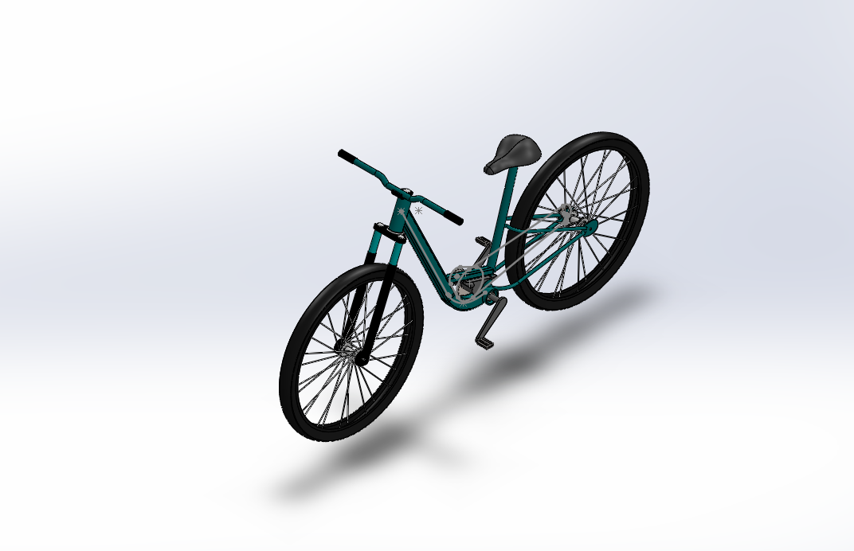

*Figure 3.0: Final design.*

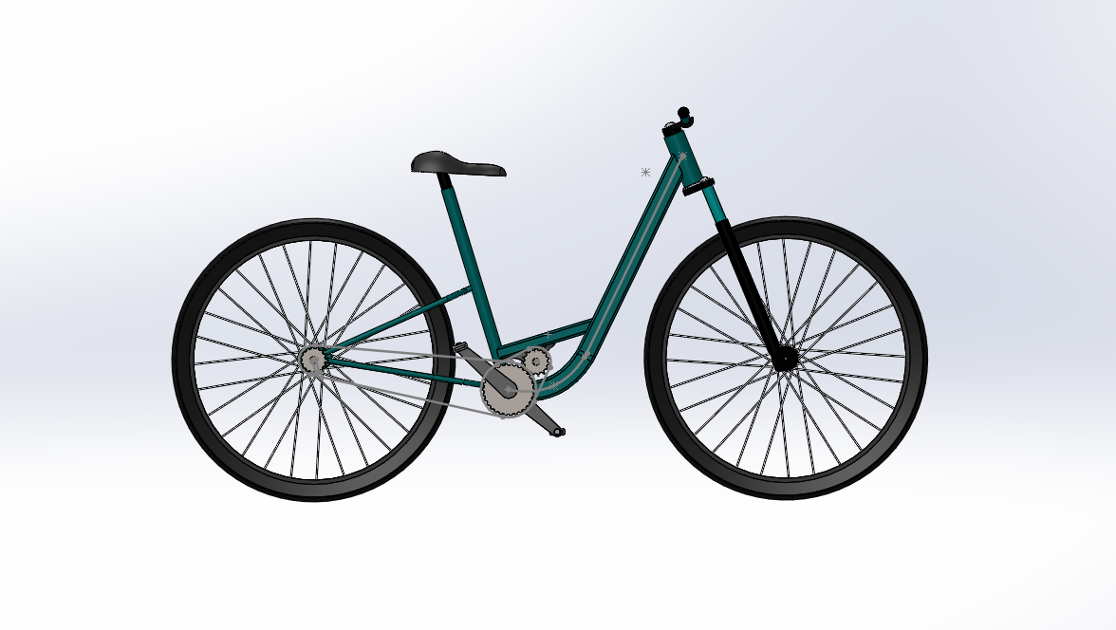

*Figure 3.1: Final design (side view).*

## 6.1 Factor of Safety for Static Loading

From our calculations, we determined the Factor of Safety (FOS) for static loading (ie. the rider is mounted on the e-bike). Including the iterative design optimization, we were able to calculate an improved FOS (see *Excel Calculations* file for Factor of Safety for Static Loading).

| **Part** | **FOS** |
| --- | --- |
| Frame | 12.2044 |
| Pedal | 122.7374 |
| Handlebar | 1.130184 |
| Seat | 4.419876 |

*Table 9. Factor of safety (static loading) for major components.*

## 6.2 Fatigue Lifetime Under Cyclic Loading

In one day, travelling takes approximately 52 cycles. This results in 187712 cycles per year and 150171 cycles for 8 years. Using the calculated Factor of Safety values, the fatigue lifetime under cyclic loading was determined to be 2617490.65 cycles or 14 years (13.944 years [actual]).

## 6.3 Auxiliary Parts

We selected a lithium-ion 48 V, 10 Ah e-bike battery as it will provide sufficient power and ample charge for numerous days of travelling at a maximum speed of 35 km/hr. The selected battery has an approximate 2000 charge cycle lifetime (full battery to empty charge), and will last 12-17 days worth of travel (35-50km on one charge). From manufacturer catalogs, we selected a 48 V reversible brushless DC motor because it was the most compatible for our selected battery and provided excellent torque specifications.

### 6.3.1 Battery Specifications

| Nominal Volt: | 48 V | Rated Capacity: | 10 Ah | Charge Voltage: | 54.6 V |
| --- | --- | --- | --- | --- | --- |
| Battery Size: | 95 mm $(Ø)$ x 410 mm | Battery Weight: | 3.7 kg | Peak Current: | 60 A |

*Table 10. Battery specifications.*

### 6.3.2 Motor Specifications

Model MMP BL87-435D-48V

| Continuous Torque: | 2.1749 Nm | Power: | 595 W |
| --- | --- | --- | --- |
| Max. Torque: | 5.536 Nm | Rated Speed: | 3618 W |
| Voltage: | 48 V |  |  |

*Table 11. Motor specifications.*

### 6.3.3 Auxiliary Assembly Components

To assemble the components, we selected the following fasteners from the manufacturer catalogs:

Wheels: 2 Alex C1000 Silver/Formula FM-21 24-inch Wheels

Bolts: 3 ½”-13 x 5” Plated Grade 5 HHC Bolts

Washers: 5 ½” Plated USS Bolt Washers

Bike Axle: 2 Delta Cycle KnoxNut Skewer Sets

Hose Clamps: 6 8”-10” Band Stainless Gear Clamps

## 6.4 Bill of Materials

| Part | Quantity | Description | Size & Specifications | Material |
| --- | --- | --- | --- | --- |
| Bike Frame | 1 | Main body of the bike (holds primary and auxiliary components). | 1.2 m x 1.635 m x 0.22 $(Ø)$ m | Aluminum 6061 Alloy |
| Bike Seat | 1 | Seat for the rider to remain rested on while riding. | 0.22m x 0.05m, 0.09m x 0.17m | Aluminum 6061 Alloy / EPDM Rubber |
| Front Fork / Handlebar | 1 | Used to steer the direction of the bike, holds front wheel. | 0.61m x 0.58 m x 0.02 $(Ø)$ m | Aluminum 6061 Alloy |
| Bike Pedals | 2 | Used by the rider to pedal. | 0.06m x 0.04m x 0.02 | Carbon Fiber |
| Gears | 1 | Composed of 3 gears. | 1 $×$ 0.0692m $(Ø)$ gear, 2 $×$ 0.12m $(Ø)$ gears | Aluminum 6061 Alloy |
| Motor | 1 | 48V reversible brushless DC motor. | Model MMP BL87-435D-48V | N/A |
| Battery | 1 | Cylinder shaped battery to power the motor | 95 mm $(Ø)$ x 410 mm | N/A |
| Wheels | 2 | Wheels of the bike, can be interchangeable by the rider | 610 mm (24-in) $(Ø)$ tires | Carbon Steel, High-Tensile |
| Bolts | 3 | Used to secure gears to the drivetrain. | 0.5 in. x 5 in. | Zinc-plated stainless steel |
| Washers | 6 | Used to reduce applied force on the gears. | 0.5 in. washers, flat. | Zinc-plated stainless steel |
| KnoxNuts Axle Set | 2 | Used to attach the bike to the frame (skewer set). | 12 mm $(Ø)$ x 120 mm | Carbon Steel, High-Tensile |
| Hose Clamps | 6 | Used to secure components to the bike frame. (2 for battery, 2 for motor, 2 for gearbox) | 8” - 10” $(Ø)$, 0.6 mm thickness | Carbon Steel, Galvanized |

# 7.0 APPENDICES

## 7.1 Appendix A: References

[1] eBicycles. (2020, October 9). *Guide to bicycle saddles*. eBicycles. Retrieved

December 10, 2021, from https://www.ebicycles.com/article/guide-to-bicycle-saddles/.

[2] Www.citybicycleco.com. (1970, May 9). *The ultimate guide to bike handlebars*.

City Bicycle Co. Retrieved December 10, 2021, from https://www.citybicycleco.com/blogs/city-bicycle-co-garage-resources/45179589-the-ultimate-guide-to-bike-handlebars.

[3] Legacki, S. G. (2017, August 10). *Types of bike pedals: A user's guide for all*

*levels*. ACTIVE.com. Retrieved December 10, 2021, from https://www.active.com/cycling/articles/types-of-bike-pedals-a-user-s-guide-for-all-levels/slide-2.

## 7.2 Appendix B: Assembly Drawing

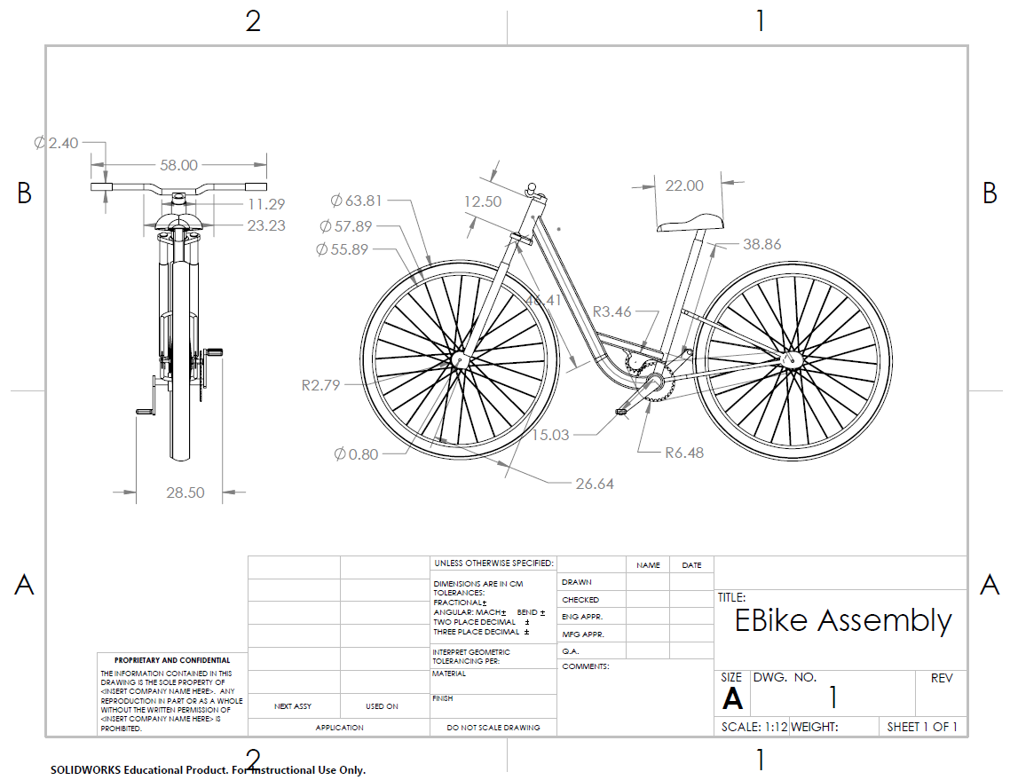

## 7.3 Appendix C: Engineering Drawings of Individual Parts

### 

### 7.3.1 Bike Frame Engineering Drawing

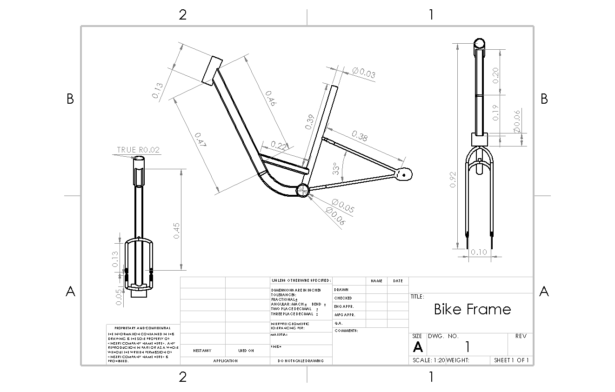

### 7.3.2 Seat Engineering Drawing

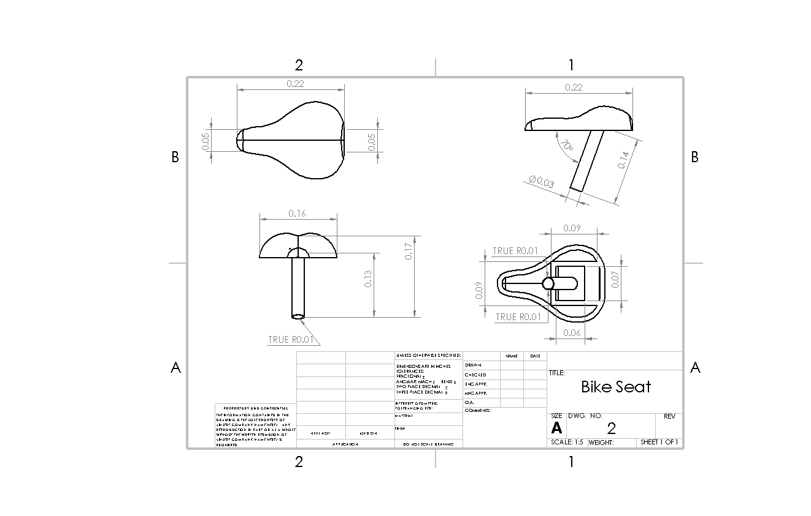

### 7.3.3 Front Fork / Handlebar Engineering Drawing

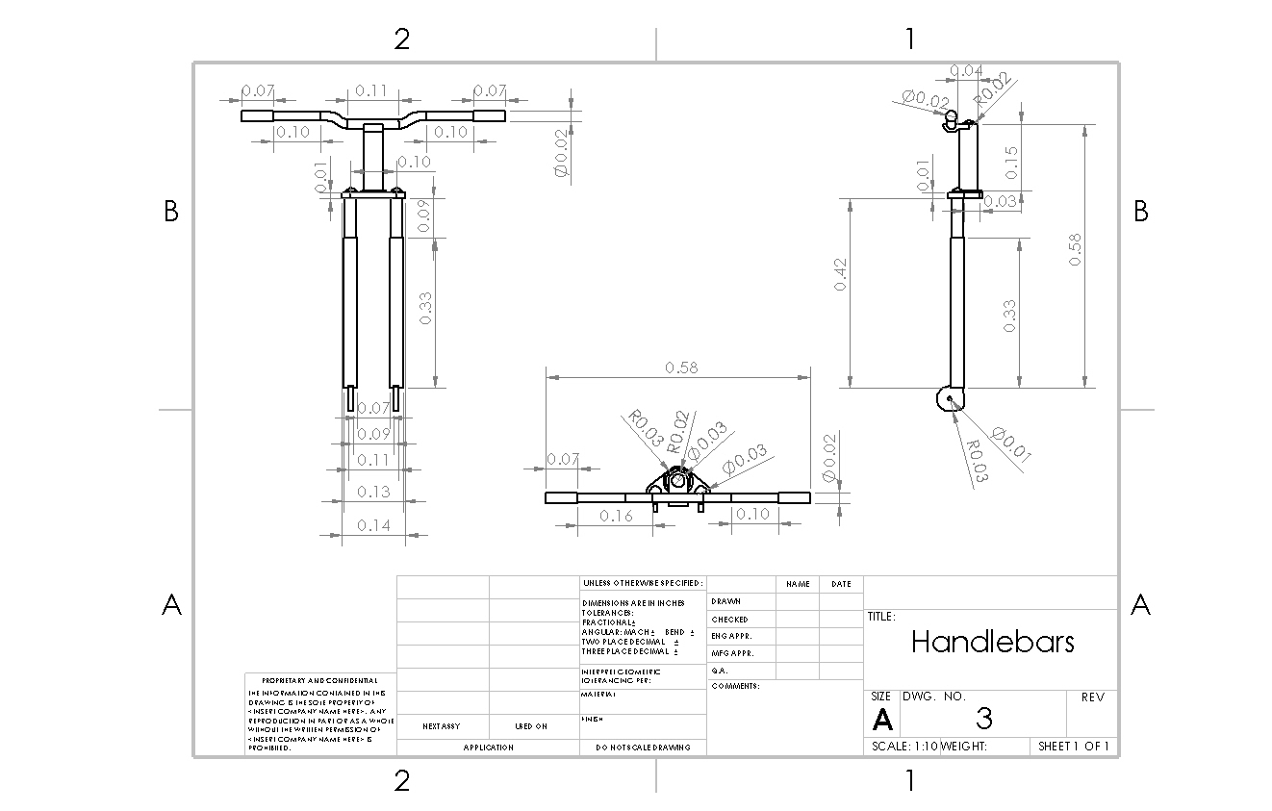

### 7.3.4 Pedal Engineering Drawing

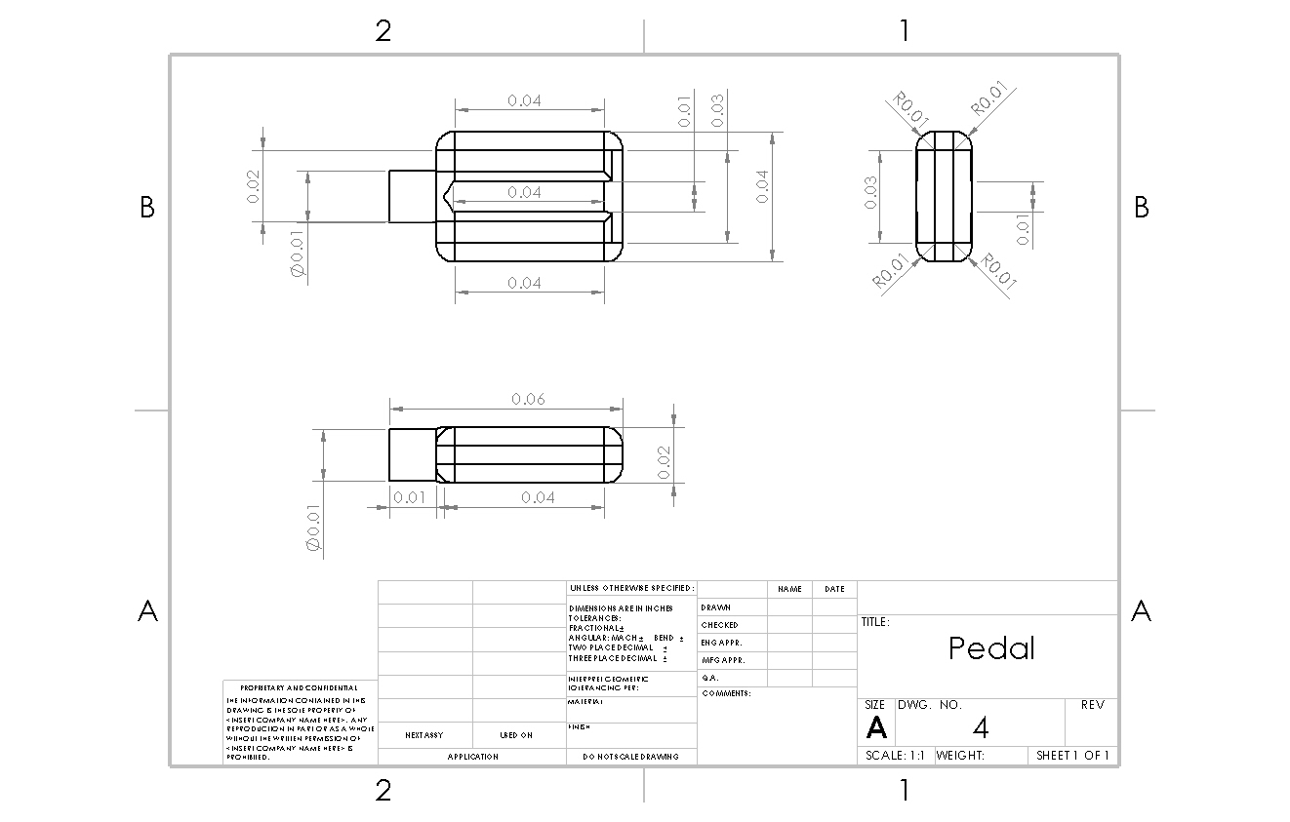

### 7.3.6 Motor Engineering Drawing

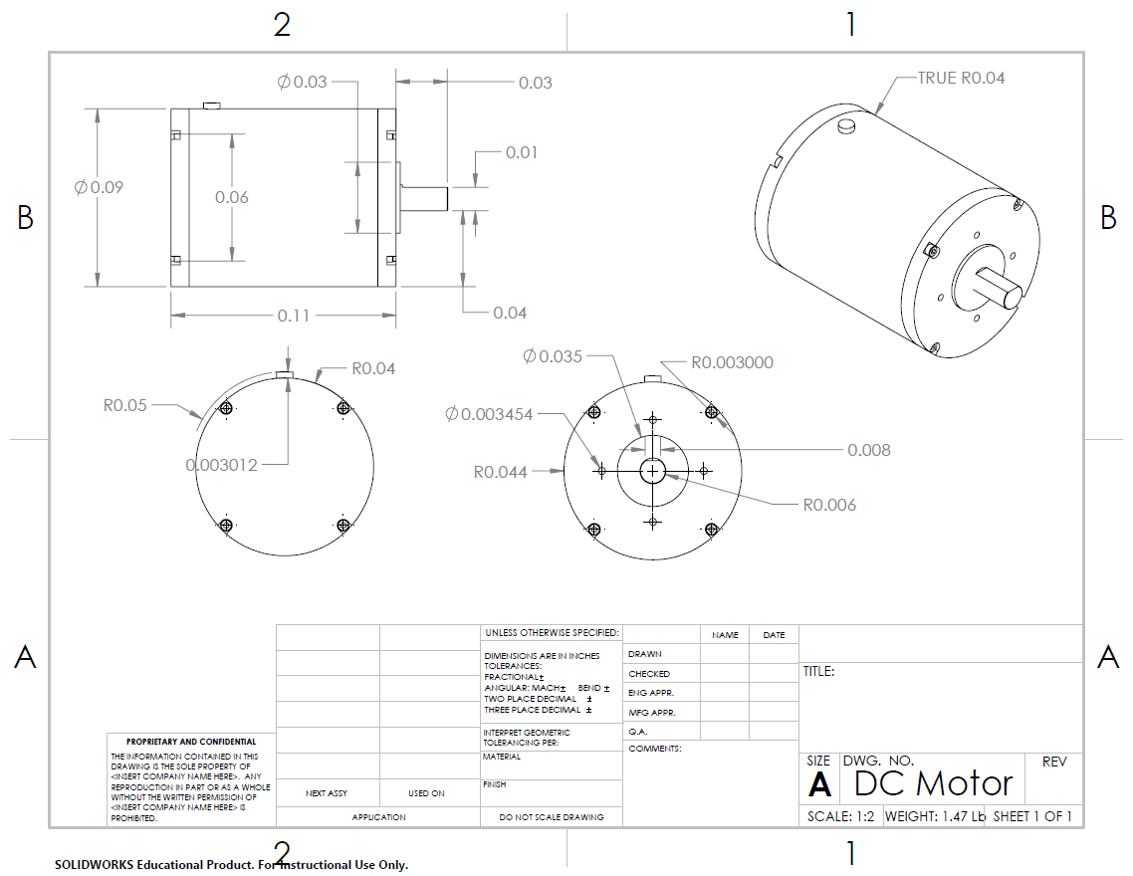

## 

## 7.4 Appendix D: Detailed Data from FEM

### 7.4.1 Stress Analysis - Frame

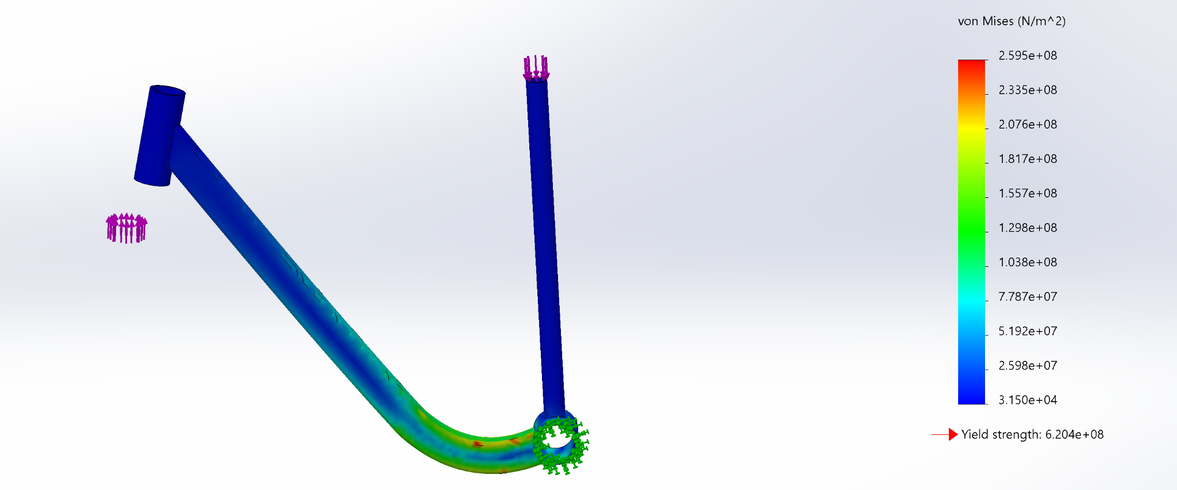

### 7.4.2 Strain Analysis - Frame

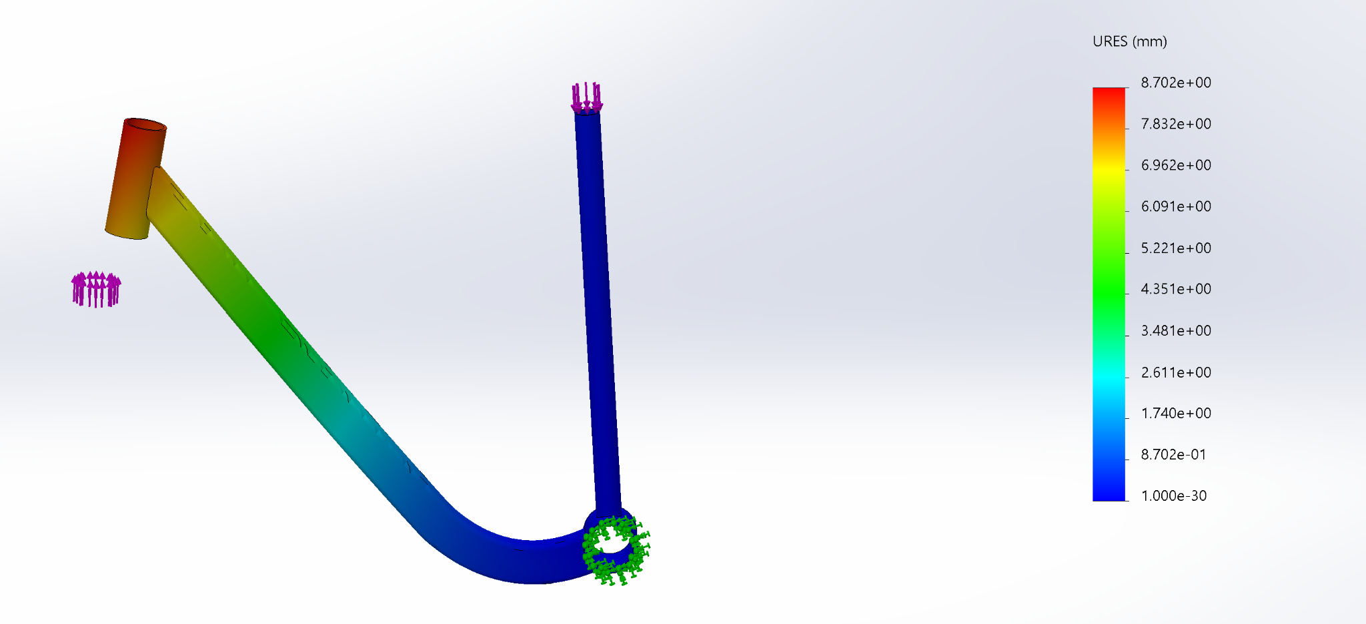

### 7.4.3 Displacement Analysis - Frame

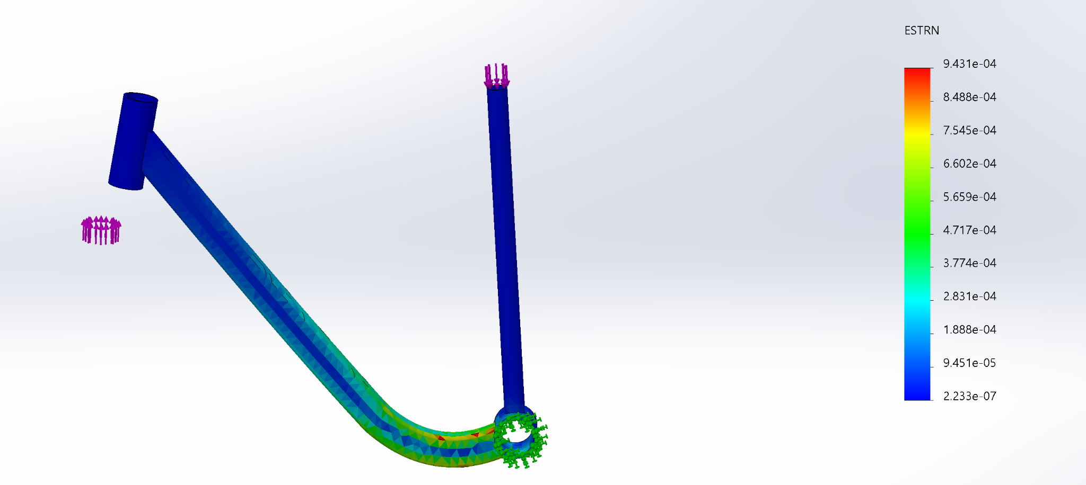

### 7.4.4 Stress Analysis - Seat

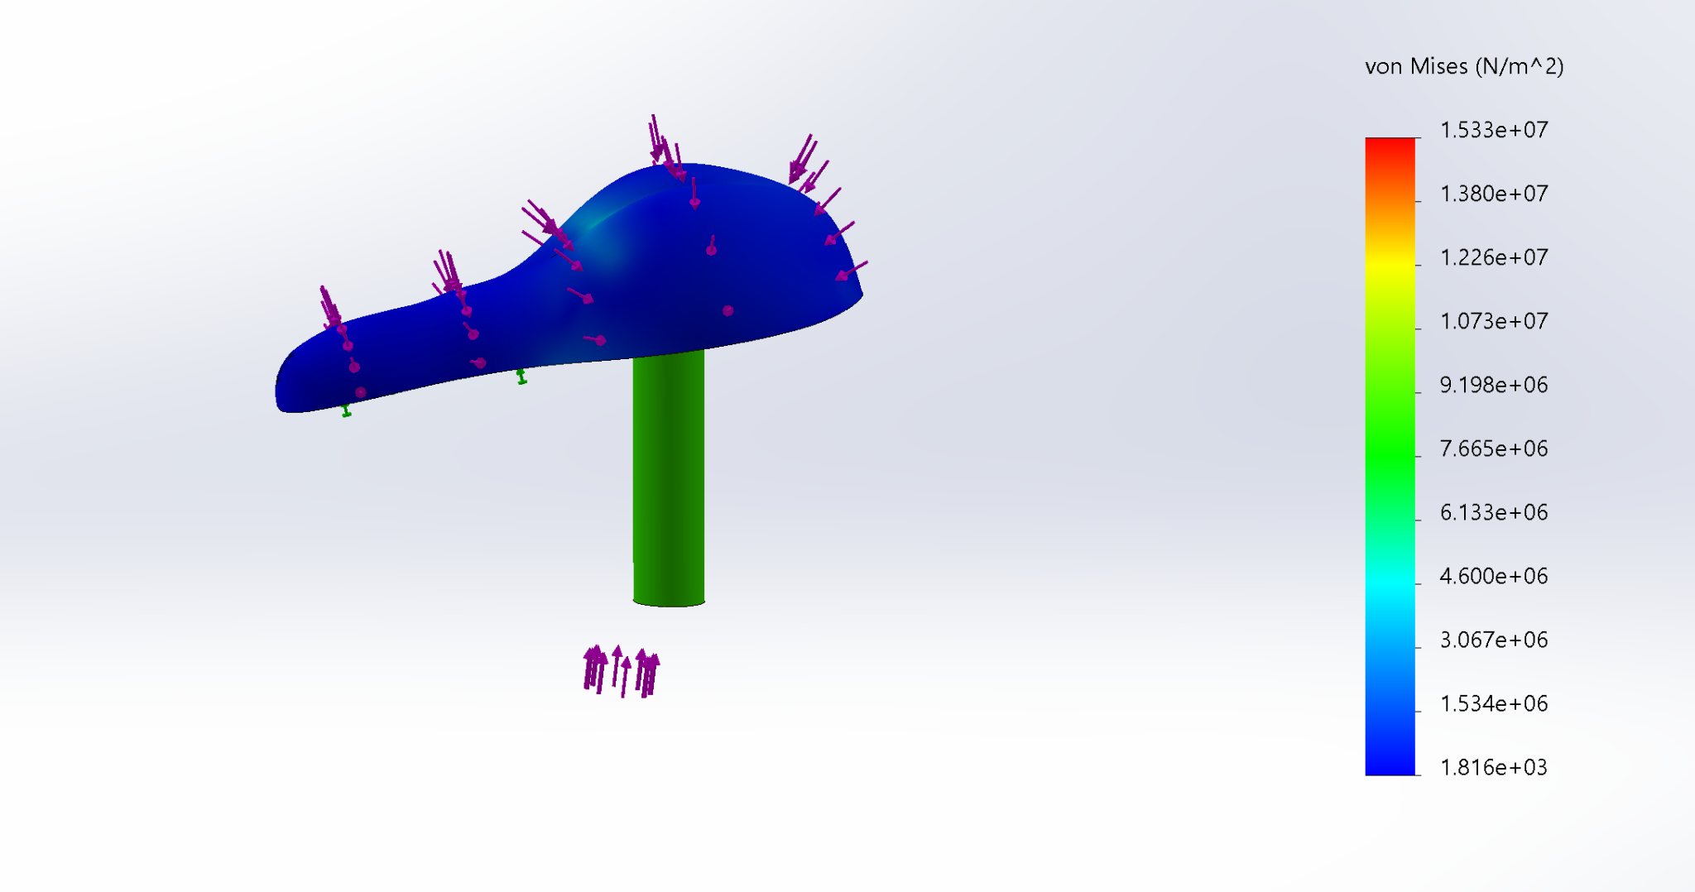

### 7.4.5 Strain Analysis - Seat

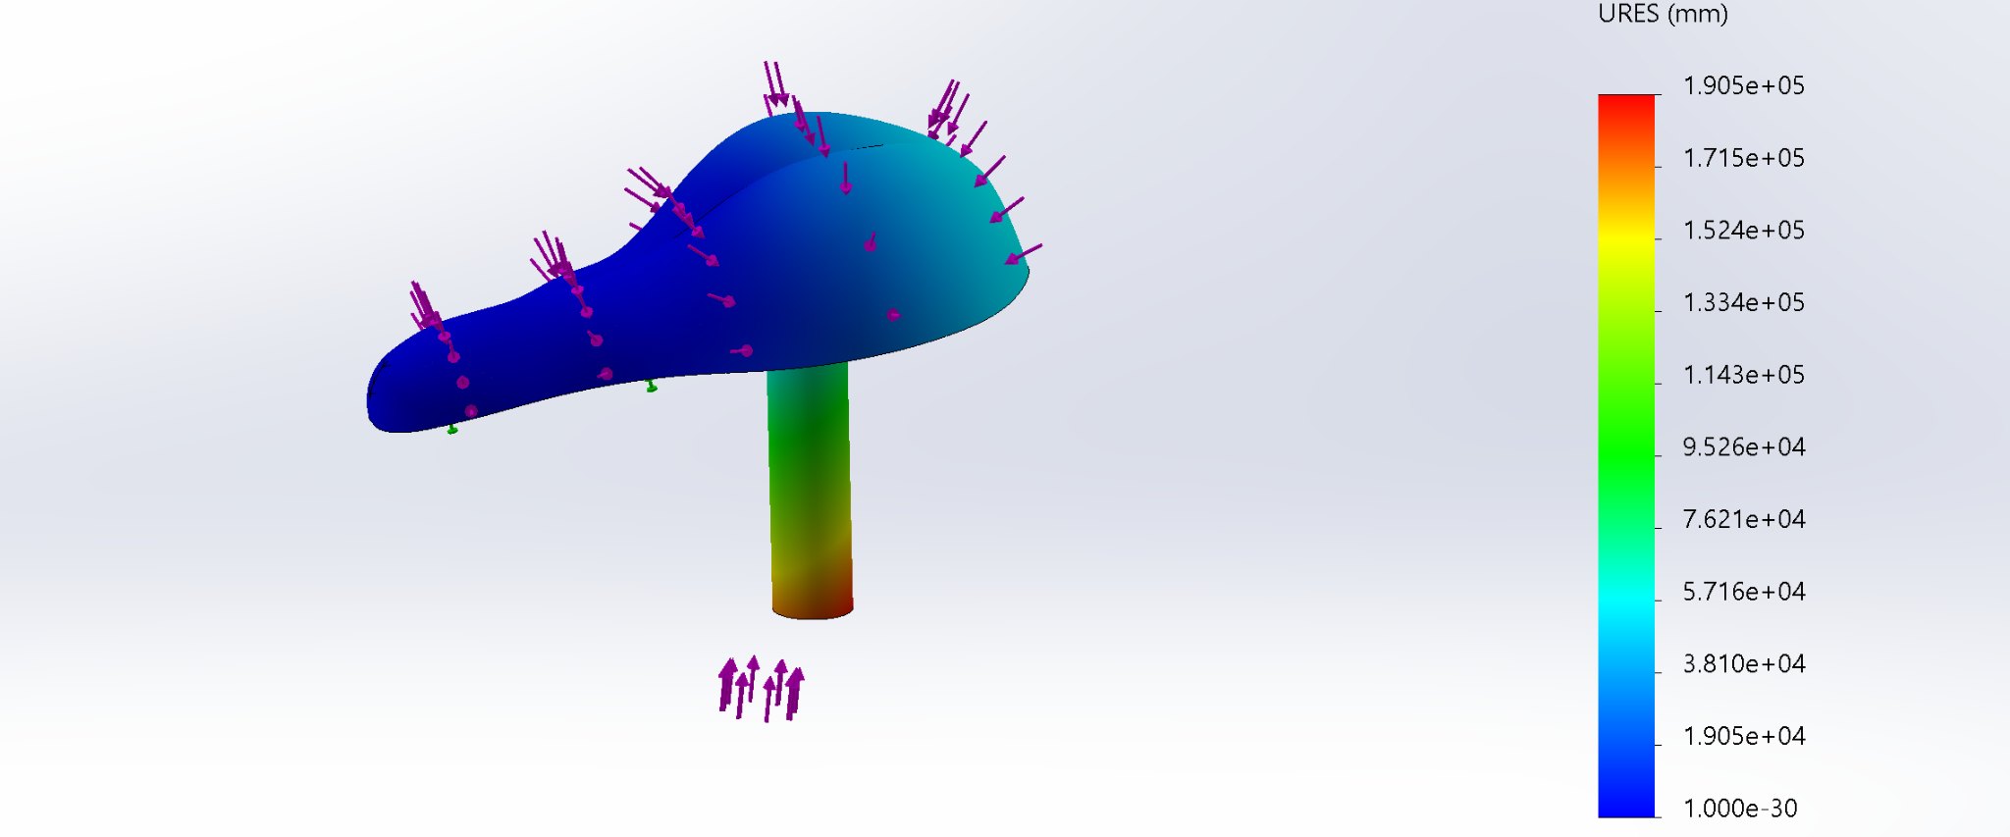

### 7.4.6 Displacement Analysis - Seat

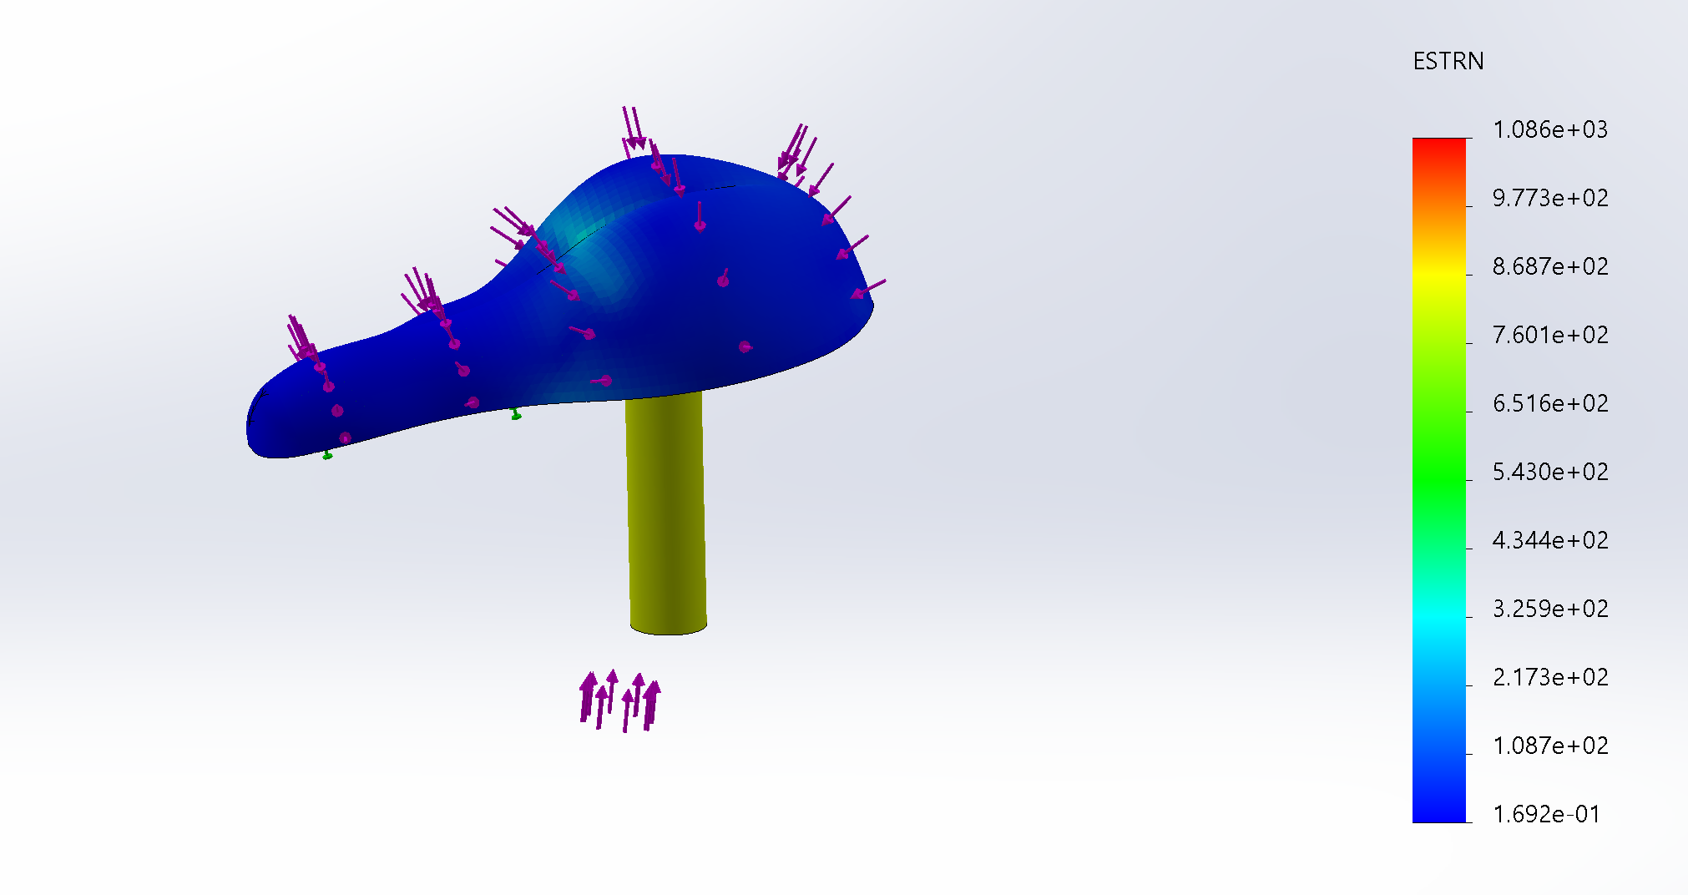

### 7.4.7 Stress Analysis - Pedal

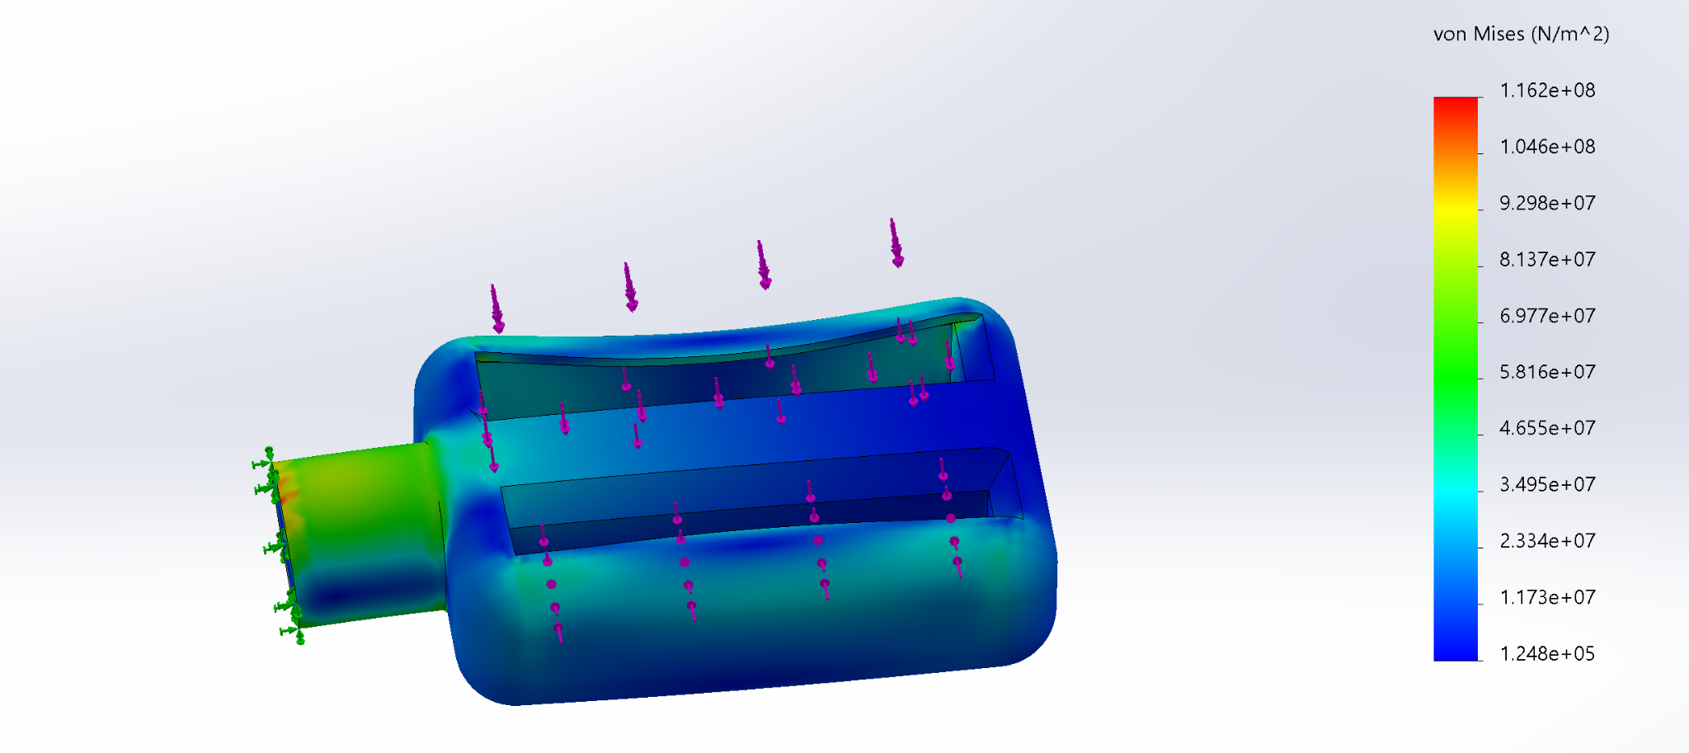

### 7.4.8 Strain Analysis - Pedal

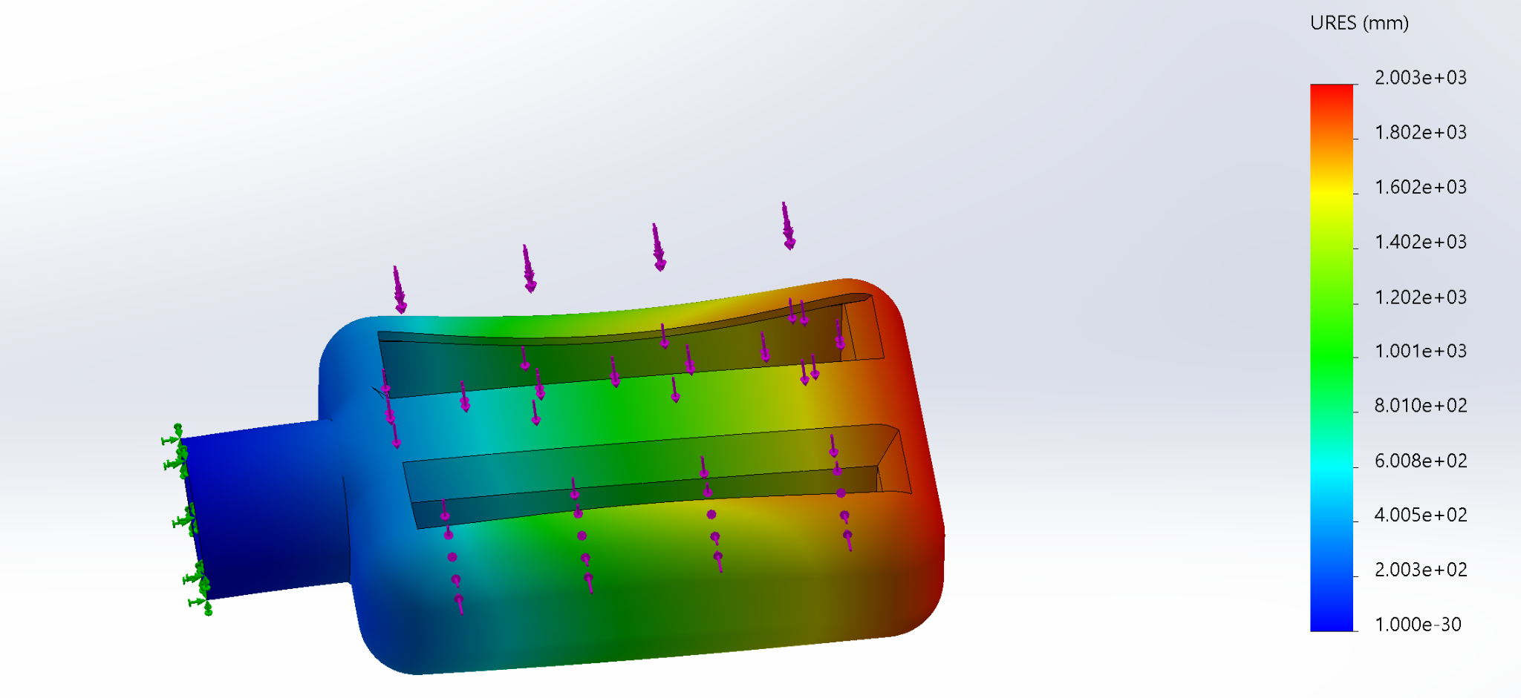

### 

### 7.4.9 Displacement Analysis - Pedal

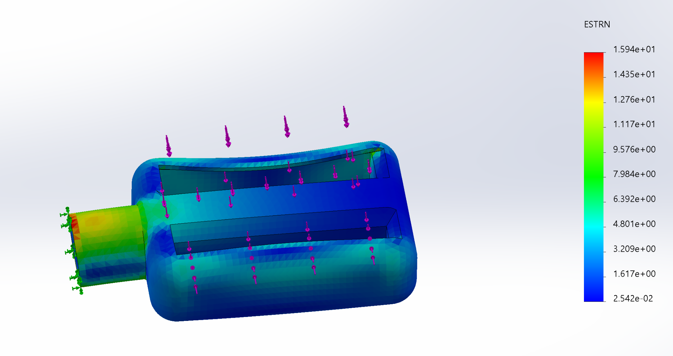

### 7.4.10 Stress Analysis - Front Fork / Handlebar

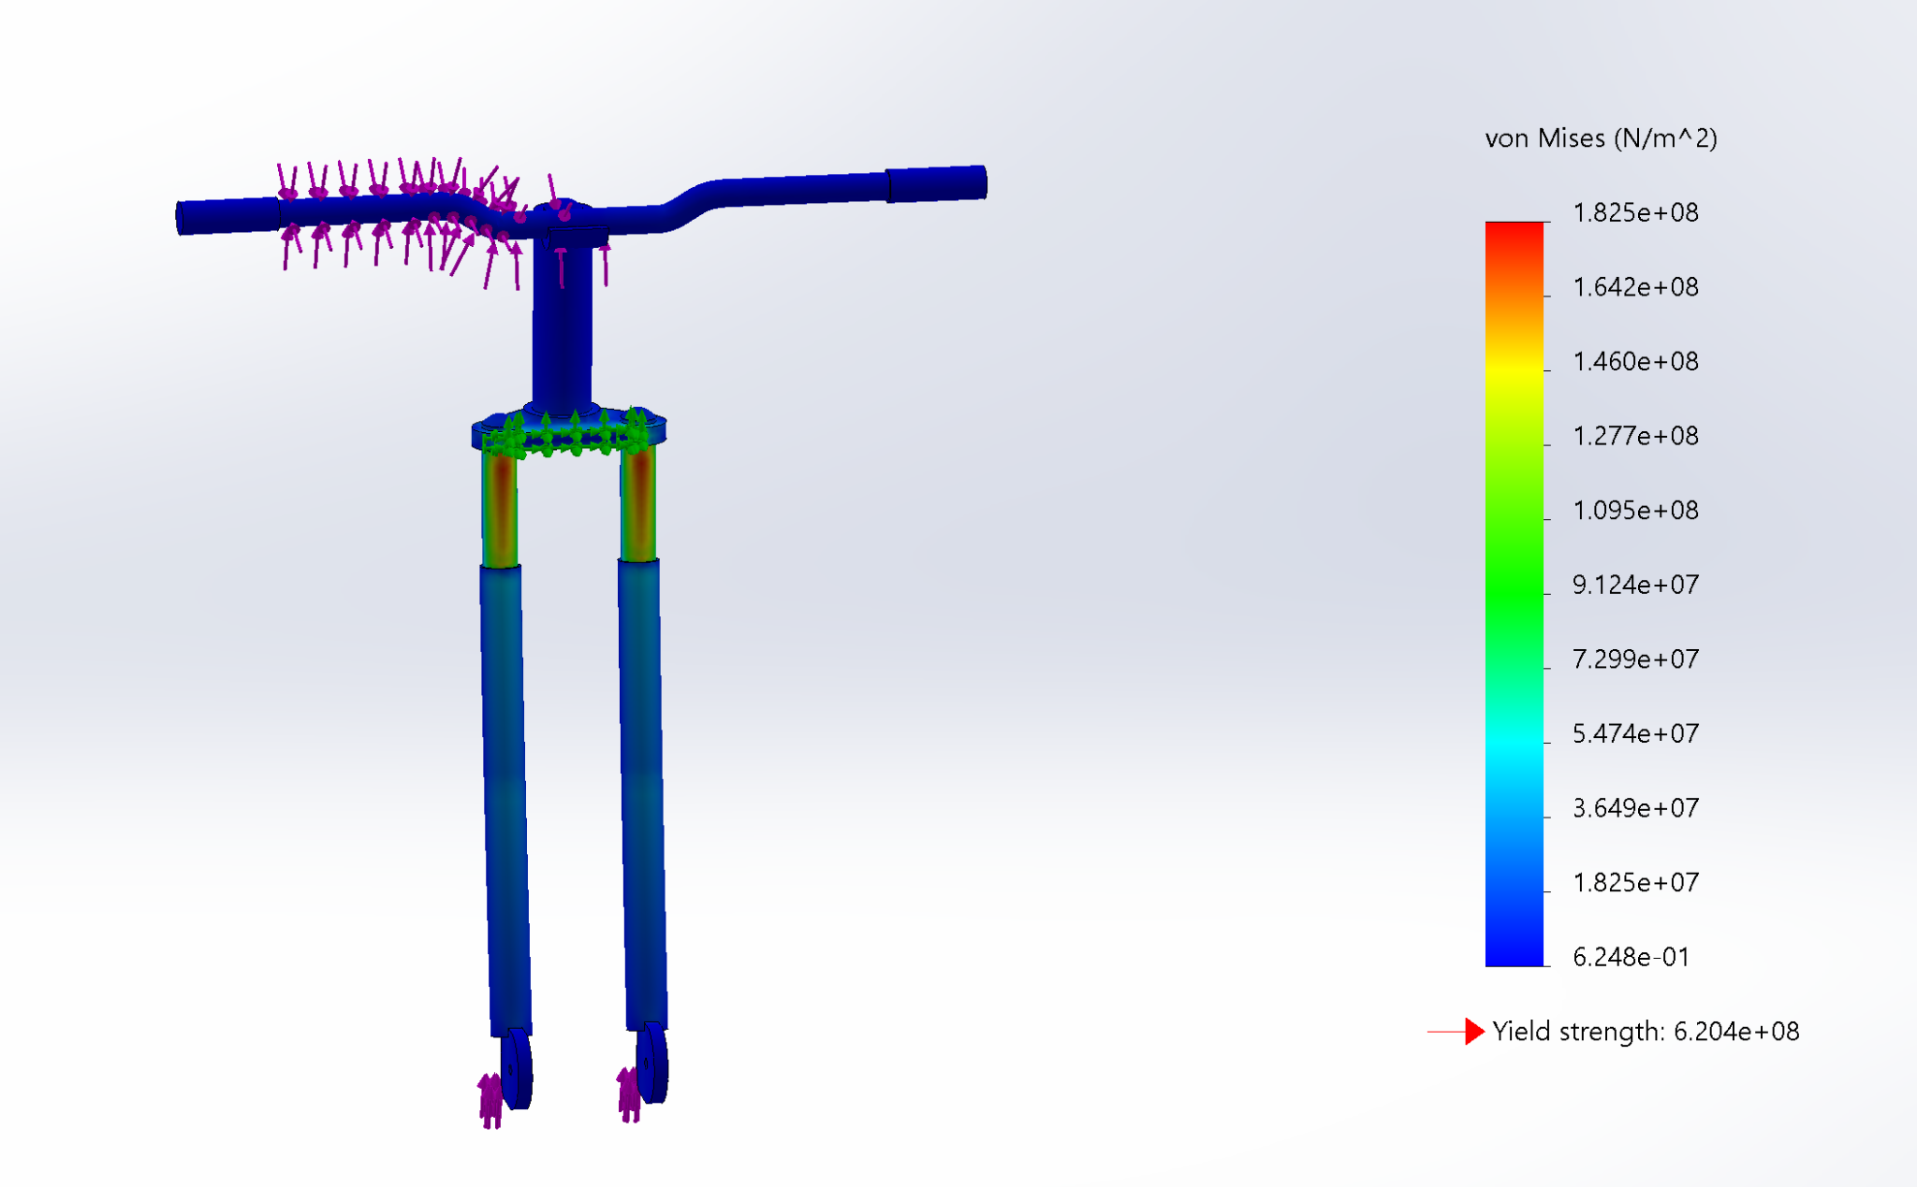

### 7.4.11 Strain Analysis - Front Fork / Handlebar

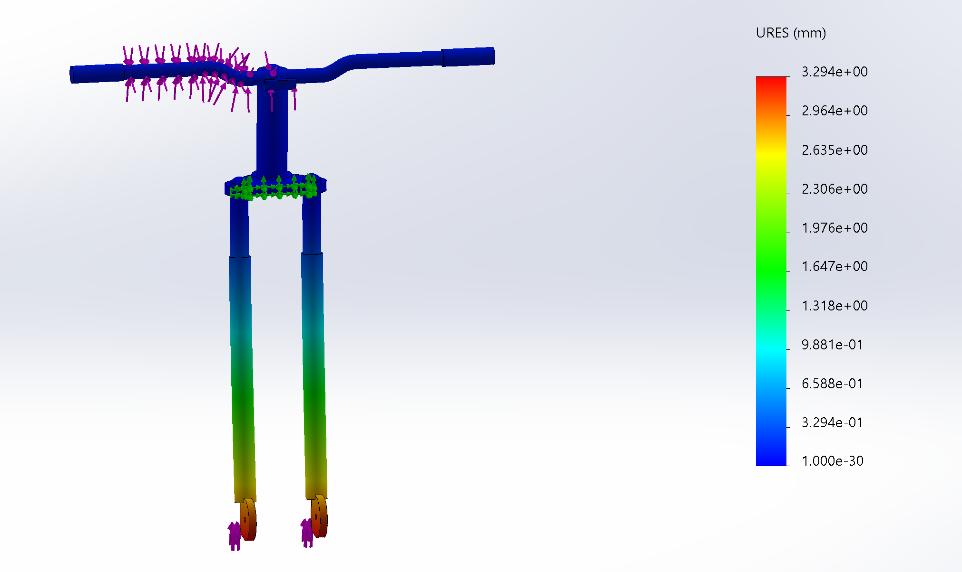

### 7.4.12 Displacement Analysis - Front Fork / Handlebar

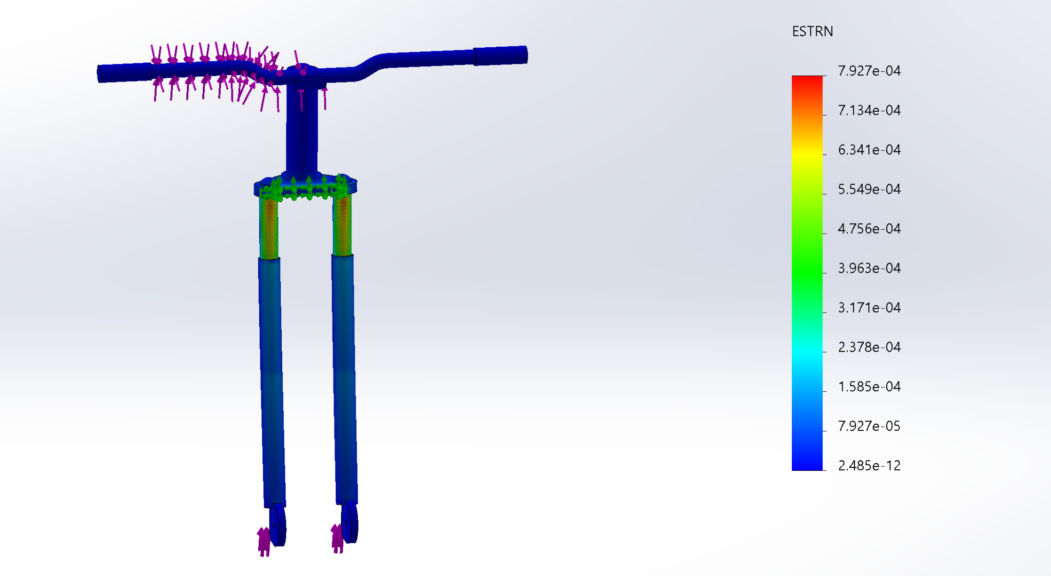

## 7.5 Appendix E: List of Tables

[1] Frame Idea Generation.

[2] Seat Idea Generation.

[3] Front Fork / Handlebar Idea Generation.

[4] Pedal Idea Generation.

[5] Gearbox Idea Generation.

[6] Material Selection for Components.

[7] Key Dimensions for Components.

[8] Factor of Safety for Major Components.

[9] Factor of Safety (Static Loading) for Major Components

[10] Battery Specifications.

[11] Motor Specifications.

## 

## 7.6 Appendix F: List of Figures

[1.0] Preliminary Design of the Electric Bike and Selected Components.

[2.0] Free Body Diagram Showing the Forces Acting on the Frame.

[2.1] Free Body Diagram Showing the Forces Acting on the Seat.

[2.2] Free Body Diagram Showing the Forces Acting on the Pedal.

[2.3] Free Body Diagram Showing the Forces Acting on the Front Fork / Handlebar.

[3.0] Final Design.

[3.1] Final Design (Side View).

## 7.7 Appendix G: Force Calculations

### 7.7.1 Frame Force Calculation

${ΣF}_{x}= 0$

${ΣF}_{y}= 0 =F_{N1}+F_{N2}-F_{g.frame}-F_{g.rider}$

$F_{N}= F_{N1}+F_{N2}$

$F_{N}= F_{g.frame}+F_{g.rider}$

$F_{N}={(m}_{frame}+m_{rider})g$

$F_{N}= (6.8 +65 [kg])(9.81 [\frac{m}{s^{2} }])$

$F_{N}= 704.358 [N]$

$F_{N1}=F_{N2}=352.179 [N]$

### 7.7.2 Seat Force Calculation

${ΣF}_{x}= 0=F_{N1}-F_{N2}$

${ΣF}_{y}= 0 ={F_{N3}-F}_{g.seat}-F_{g.rider}$

${F_{N3}=F}_{g.seat}+F_{g.rider}$

${F_{N3}=(m}_{seat}+m_{rider})g$

$F_{N3}=(1.6 +65 [kg])(9.81 [\frac{m}{s^{2} }])$ $F_{N3}=653.346 [N]$

### 

### 7.7.3 Pedal Force Calculation

${ΣF}_{x}= 0$

${ΣF}_{y}= 0=F_{N}-F_{app}-F_{g, pedal}$ $F_{N}=F_{app}+F_{g, pedal}$ ${F_{N}=(m}_{pedal}+m_{rider})g$

$F_{N}=(0.28+65/2[kg])(9.81 [\frac{m}{s^{2} }])$

$F_{N}=321.572 N$

### 7.7.4 Handlebar Force Calculation

${ΣF}_{x}= 0$

${ΣF}_{y}= 0={F_{N1}+F_{N2}-F}_{g.handlebar}$

$F_{N1}+F_{N2}= F_{g.handlebar}$

$F_{N12}=m_{handlebar} g$

$F_{N12}=(4.2 [kg])(9.81 [\frac{m}{s^{2} }])$

$F_{N12}=41.202 N$

## 7.8 Appendix H: Attribution Table

| **Section** | **Nathan** | **Amish** | **Muhammad** | **Obada** | **TOTAL** |
| --- | --- | --- | --- | --- | --- |
| Idea Generation + Concept Selection | 25% | 75% | 0% | 0% | **100%** |
| Preliminary Design | 35% | 25% | 20% | 20% | **100%** |
| Analysis and Iterative Design | 20% | 0% | 40% | 40% | **100%** |
| Final Design | 20% | 0% | 40% | 40% | **100%** |
| **TOTAL** | **25%** | **25%** | **25%** | **25%** |  |

## 